School of Science  Department of Geology and Geoenvironment | 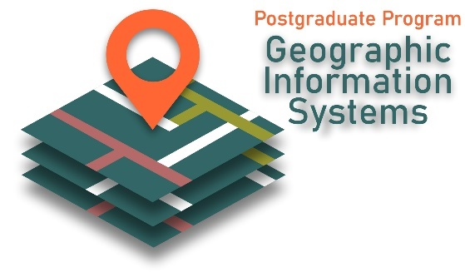

TITLE
Master thesis
NAME SURNAME
R.N.

Athens, Month Year

School of Science
Department of Geology and Geoenvironment

TITLE
Master thesis
NAME SURNAME
R.N.

Supervisor: Name Surname, Title (e.g. Professor NKUA)

Three‐member Examination Committee
Name Surname, Title (e.g. Professor NKUA)
Name Surname, Title (e.g. Professor NKUA)
Name Surname, Title (e.g. Professor NKUA)

Athens, Month Year

NON-INFRINGEMENT OF INTELLECTUAL PROPERTY
Infringement of Intellectual Property is defined to be the total or partial reproduction of the intellectual work of other person/persons, or the appropriation of the intellectual work of other person/persons and its presentation as intellectual work of the student signing and submitting a Dissertation. The Department of Geology and Geoenvironment is ardently opposed to such practices and vehemently condemns such conduct by its Postgraduate Students. In cases of apparent or voluntary infringement of intellectual property, the competent organs of The Department are authorized to investigate and impose sanctions that may result in the expulsion of students from the PSP. In compiling their Postgraduate Dissertation, students are obliged to respect the following guidelines fully and unreservedly:
- The Postgraduate Dissertation must be the exclusive intellectual product of the student who signs and submits it.
- To copy or paraphrase the work of a third party constitutes infringement of intellectual property and is a serious offense. The offense includes appropriation of the intellectual property of fellow students as well as the verbatim reproduction or appropriation of material from published sources (books, textbooks, dissertations, scientific articles). The appropriation and usage of material copied from websites and digital documents of any kind is equally serious to the appropriation and usage of material copied prom printed sources or data bases.
- Utilization of excerpts from the work of third parties is acceptable if and only if the source of the excerpt is clearly referenced. If verbatim quotation of excerpts from the work of a third party is necessary, then the use of quotes or appropriate footnotes/ endnotes is mandatory in order for the source to be acknowledged.
- The paraphrase of text from the work of third parties constitutes infringement of intellectual property.
- The sources of information used and/or quoted in the Dissertation must be listed in the “References Section” attached to the Dissertation.
- The infringement of intellectual property, once demonstrated, is subject to severe sanctions that may result in expulsion from the PSP and are completely specified in Art. 10 of the “Regulation of Studies”.

I hereby declare that the Postgraduate Dissertation that I herewith submit does not contain elements of Infringement of Intellectual Property, as these are defined in the above Declaration whose terms I have read, understood, and unreservedly accept. I unreservedly provide assent for a digital copy of my Postgraduate Dissertation to be inspected either manually or by competent software in order to confirm that elements of Infringement of Intellectual Property are totally absent from my Dissertation.

Date Signature

ABSTRACT
The abstract includes the purpose-subject of the thesis, the methodology, the main steps followed and finally the main results. After the end of the abstract, 5 key words should be provided. The total length of the abstract should be 1-2 pages.

KEYWORDS: e.g. geographic information systems, modelling, geoenvironment

ΠΕΡΙΛΗΨΗ
Εφόσον η εργασίας είναι γραμμένη στην αγγλική γλώσσα, τότε θα πρέπει να υπάρχει και μία εκτεταμένη περίληψη της εργασίας σας και των λέξεων – κλειδιά και στα ελληνικά.

Λέξεις κλειδιά: π.χ. Γεωγραφικά Συστήματα Πληροφοριών, Μοντελοποίηση, Γεωπεριβάλλον

ACKNOWLEDGEMENTS

Contents
ABSTRACT 4
ΠΕΡΙΛΗΨΗ 5
ACKNOWLEDGEMENTS 6
1. Introduction 8
1.1 Text format 8
1.2 Figures and tables 8
1.2.1 Tables 8
1.2.2 Figures 9
References 10
Appendix I 11

1. Introduction

1.1 Text format
You may use this template to format your thesis. Please use the styles provided to format your text so that there is a uniform appearance of all theses.
The page size should be A4. All page margins should be 2.3 cm.
For the headings you can find the corresponding styles format in the Tab Home, Styles.
For the main text, you may use the style “Normal”.
For list paragraph use the following format, which you will find in styles as “List Paragraph”:
- Text, text, text
- Text, text, text

1.2 Figures and tables
- Figures: All images/photographs must be uniquely numbered and a caption, as in this template.
- Tables: All tables must be uniquely numbered and captioned at the top, as in this template.

1.2.1 Tables
The tables and their captions should be formatted as follows. You may use the style “Caption” for styling your captions.
Table 1.1 Assessment criteria for geomorphosites (Reynard et al. 2016)
Scientific value | Additional values | Other characteristics
integrity | ecological value | visit conditions (accessibility etc.)
representativeness | aesthetic value | educational value
rareness | cultural value | protection, management, damages etc.
palaeogeographical interest | economic value

1.2.2 Figures
Below you see an example of a figure, with its corresponding caption. The caption is placed below the image.

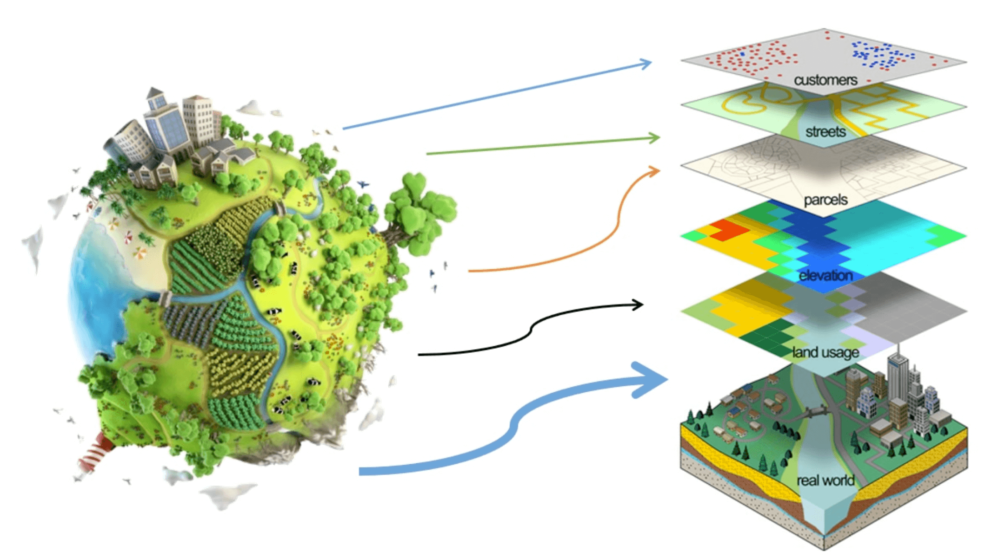
Figure 1.1 GIS layers.

References
Reynard, E., Perret, A., Bussard, J., Grangier, L., & Martin, S. (2016). Integrated Approach for the Inventory and Management of Geomorphological Heritage at the Regional Scale. Geoheritage, 8(1), 43–60. https://doi.org/10.1007/s12371-015-0153-0

Appendix I
The appendices present data that are not required to appear in the main part (body) of the Thesis (such as statistical analysis tables, questionnaires, etc.) but contribute to the understanding of the subject. Essentially, the appendices present all those elements that are complementary to the main part of the work.
Please note that it is not mandatory for your thesis to have appendices.

Citations to past work by researchers whose ideas, theories, or research influenced your own work in any way is a very critical point in writing your paper. You may use a software such as Mendeley to organize and format your thesis citations. In any case your references should be style using a specific reference style, and the proposed one is APA style referencing. You may use the style “References” to format the references text style, as below.

